ITRAINONLINE MMTK

BASIC WIRELESS INFRASTRUCTURE AND TOPOLOGIES HANDOUT
Developed by: Sebastian Buettrich, wire.less.dk
Alberto Escudero Pascual, IT +46

Table of Contents
1. About this document 1
1.1 Copyright information 1
1.2 Degree of difficulty 2
2. Introduction 2
3. Basic network topologies 2
3.1 Relevant network topologies in wireless networking 3
4. Wireless Components 5
4.1 Access point 5
4.2 Wireless clients 5
5. Wireless modes 5
5.1 Ad hoc Mode (IBSS) 6
5.1.1 Case 1: Point to Point 6
5.2 Infrastructure (BSS) 6
5.2.1 Case 1: Star 7
5.2.2 Case 2: Point to Point (PtP) 7
5.2.3 Case 3: Repeating 8
5.2.4 Case 4: Mesh 8
6. Real life examples of wireless infrastructures 9
7. Conclusions 11

About this document
These materials are part of the ItrainOnline Multimedia Training Kit (MMTK). The MMTK provides an integrated set of multimedia training materials and resources to support community media, community multimedia centres, telecentres, and other initiatives using information and communications technologies (ICTs) to empower communities and support development work.

Copyright information
This unit is made available under the Creative Commons Attribution-ShareAlike 2.5 License. To find out how you may use these materials please read the copyright statement included with this unit or see http://creativecommons.org/licenses/by-sa/2.5/.

Degree of difficulty
The degree of difficulty of this unit is basic.

Introduction
This unit considers the physical shape and the logical layout of basic network topologies in general and wireless topologies in specific. A set of common topologies will be presented and their respective relevance in wireless implementations will be discussed.
The different modes of wireless networks will be described and practical examples with general setup instructions are outlined for a set of typical wireless cases. By doing so, we aim to give the reader necessary skills to be able to identify and plan suitable topologies for real scenarios.

Basic network topologies
A network topology is the layout of connecting links between nodes in a network. Networks can take many different forms depending on how nodes are interconnected. There are two ways of describing the topology of a network: physically or logically. The physical topology refers to the configuration of cables, computers and other network devices while the logical topology refers to higher abstract level, for example by considering the method and flow of information transfer between nodes.

Below follows a brief description of a set of basic network topologies.

Topology | Description
Bus | All nodes are connected to a shared/common cable. Ethernet networks are normally bus topologies.
Star | Each node is connected directly to a central network hub or concentrator. All data in a star topology passes though the hub before reaching its destination. This topology is common in Ethernet and Wireless LAN.
Line (or multi-hop) | A set of nodes connected in a line. Each node is connected to its two neighbouring nodes except for the end nodes that have only one neighbouring node each.
Tree | A combination of a bus and a star topology. A set of star configured nodes are connected to a bus backbone.
Ring | All nodes are connected to one another in the shape of a closed loop, so that each node is connected directly to two other devices. Typically backbone infrastructure with optical fibre.
Full mesh | A direct link between all pairs of nodes. A full mesh with n nodes requires n(n-1)/2 direct links. Due to its character, it is an expensive topology but very reliable. Mainly used within military applications.
Partial mesh | Some nodes are organized in a full mesh scheme while others are just connected to one or two nodes in the network. Partial mesh topology is less expensive than full mesh but are of course not as reliable since the number redundant links are reduced.

Table 1: Description of basic network topologies

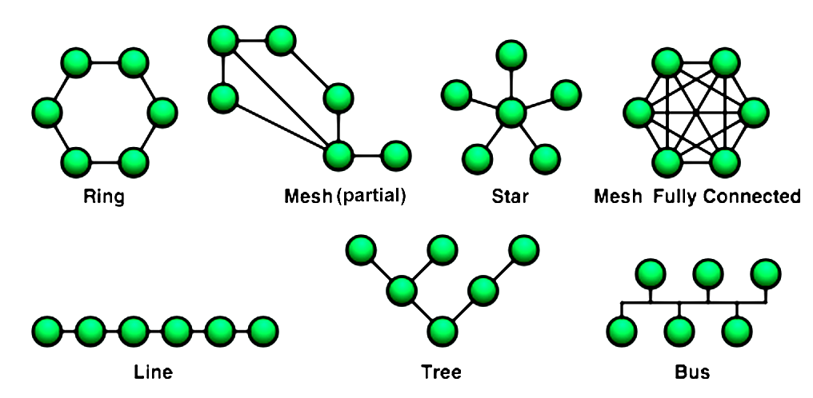
Source: Wikipedia.org
Image 1: Basic network topologies

Relevant network topologies in wireless networking
Below follows some general remarks that will help you to understand how and why some network topologies can or can not be apply to wireless networking. These remarks might sound trivial, but their understanding is elementary for successful wireless networking.

Wireless communication needs no medium
While wireless communication obviously needs no cables or such, it also needs no other medium, air, ether or other carrier substance. In wireless networking, a line drawn in a network diagram is equivalent to a (potential) connection that is being made, i.e. it is not to a cable or another physical representation.

Wireless communication is always two-way (bidirectional)
No rules without an exception, in the case of fully passive sniffing or eavesdropping, the communication is not bidirectional.
This bi-directionality exists regardless if we talk about transmitters or receivers, masters or clients.

A radio is a radio and its further role is determined by software
This software determines the radio cards' behaviour down to OSI Layer 1 and 2, i.e. the physical and link layer.

With these general remarks in mind, we can evaluate the relevance of network topologies for wireless networking.

Topology | Visual representation | Wireless relevancy
Bus | 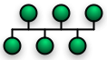 | Not applicable. Studying the bus topology we will notice that each node is connected to all other nodes and since the place where one line meets the other lines is of no significance in the wireless case, this topology is fully equivalent to a (full) mesh network operating in one single channel.
Star |  | Yes , the standard topology of wireless network.
Line (multi-hop) |  | Yes, with two or more elements. A line of two nodes is a PtP link.
Tree | 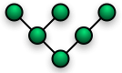 | Yes, typically wireless ISPs.
Ring | 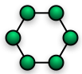 | Yes, possible but rarely found
Full mesh | 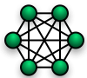 | Yes, but mostly partial mesh
Partial mesh | 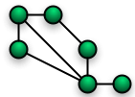 | Yes.

Table 2: Topologies in wireless networks

Wireless Components

Access point
An access point is a wireless “hub”. The transmitter/receiver connects together the wireless nodes and typically also bridge them to the wired network. A set of (coordinated) access points can be connected together to create a large wireless network.

From the point of view of the wireless clients (think in the laptops or mobile stations), an access point provides a virtual cable between the associated clients. This “wireless cable” connects both the clients together but also the clients to the wired network.

An access point should be distinguished from a wireless router that is very common on the market today. A wireless router is a combination of an access point and a router and can perform more complex tasks than an access point. Consider a wireless router as a wireless bridge (between wireless and wired Ethernet) and a router (IP routing features).
Clients connect to the access points by knowing their “name”. This way of identification is known as the Service Set Identity (SSID) and it should be shared by all members of the specific wireless network. All the wireless clients and access Points within an Extended Service Set (ESS) must be configured with the same ID (ESSID).
When talking about SSID think in the “label of an Ethernet socket”. Connecting to a wireless network with SSID “x” is equivalent to plugging your computer to a Ethernet socket on the wall identified with the tag “x”.
For further details, see unit “Access point configuration”

Wireless clients
A wireless client is any wireless station that connects to a wireless Local Area Network (LAN) to share its resources. A wireless station is defined as any computer with an installed wireless network adapter card that transmits and receives Radio Frequency (RF) signals.

Some common wireless clients are laptops, PDA's, surveillance equipment and wireless VoIP phones.

Wireless modes
There are two fundamental wireless modes defined in the 802.11 suite of standards:

- Ad Hoc
- Infrastructure

It is important to understand that these modes are not always directly reflected in the topology. For example, a point to point link can be in ad hoc or infrastructure mode and one could imagine a star built out of ad hoc connections.
The mode can be seen as a basic setting of the individual radio card of a node rather than a characteristic of the whole infrastructure.

Ad hoc Mode (IBSS)
Ad hoc mode, also known as Peer-to-Peer, is a method for wireless clients to directly communicating with each other. By allowing wireless clients to operate in ad-hoc mode, there is no need of involving any central access points. All nodes of an ad hoc network can communicate directly with the other clients.

Each wireless client in an ad hoc network must be set its wireless adapter in ad hoc mode and use the same SSID and “channel number”.
An ad-hoc network consists normally of a small group of devices located close to each other. Performance decreases as the number of nodes in the ad hoc network grows. In order to bridge an ad hoc network to a wired LAN or to the Internet, a special gateway must be installed.
The Latin work 'ad hoc' means “for this purpose” but are commonly used for an improvised and often impromptu events or solutions.
Independent Basic Service Set (IBSS) is the denotation of the ad hoc mode in IEEE 802.11 networks.

Case 1: Point to Point
Ad hoc mode can be used when you wish to connect two stations directly e.g. building to building. It can also be used inside of an office between a set of workstations.

Setting | Node 1 | Node 2
Mode | ad hoc | ad hoc
SSID | MY_SSID | MY_SSID
Channel | Need to agree and know each others | Need to agree and know each others
IP address | Typically fixed | Typically fixed
Table 3: A typical setup for an ad hoc network.

If one node is networked (e.g. Internet or intranet), it may or may not make that network available to the other node.

Infrastructure (BSS)
Opposite to ad-hoc mode where there is not a central element, in infrastructure mode there is a “coordination” element: an access point or base station. If the access point is connected to the wired Ethernet network, the wireless clients can access the fixed network via the access point.
When several access points and wireless clients are interconnected, they must be configured to use the same SSID. If you want to ensure that the overall capacity of your network is maximized do not configure all the access points in the same physical area to use the same channel. The clients will discover (by means of scanning) which channel the access point is using and hence, there is no need for the clients to know the channel number in advance.
Basic Service Set (BSS) is the denotation of the infrastructure mode in IEEE 802.11 networks.

Case 1: Star
The star topology is by far the most common infrastructure for wireless networks. It is the typical topology for a hotspot, weather it is in a airport or a Telecenter. The star topology is the typical WISP setup (think in a point to multipoint link). This type of networks are often extended into trees or combination with other topology elements.

Setting | AP/Gateway | Node x1
Mode | Infrastructure | Infrastructure
SSID | Sets MY_SSID | Connects to MY_SSID
Channel | Sets channel x | Discovers the channel
IP address | Typically runs DHCP server  (if router features are available) | Typically gets IP via DHCP lease
Table 4: A typical setup for a star topology

Case 2: Point to Point (PtP)
Point to point (PtP) links are a standard element of a wireless infrastructure. On topology level they may be part of a star topology, a simple 2-point line or other topology. The mode of a PtP link can be ad hoc or infrastructure.

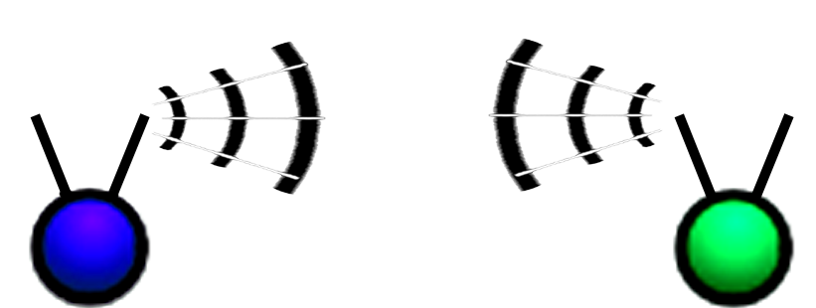
Image 2: A point-to-point link in ad hoc or infrastructure mode.

Setting | Node 1 | Node 2
Mode | Any | Any
SSID | MY_SSID | MY_SSID
Channel | Will agree and know each others | Will agree and know each others
IP address | Typically fixed | Typically fixed
MAC address | Might be fixed to one another's MAC | Might be fixed to one another's MAC
Table 5: A typical setup for a PtP link. The mode can be ad hoc or infrastructure but both nodes must be in the same mode.

For long distance PtP links advanced wireless settings are needed are needed to improve performance.

Case 3: Repeating
Repeating typically becomes necessary when the direct line of sight is obstructed or the distance is too long for one single link. The wired equivalent of wireless repeating is a hub.
The setup of repeating depends on hardware and software specific factors and is difficult to describe in one generic way.
The repeating unit may consist of one or two physical devices and have one or two radios. A repeater can also be seen as a receiving client and a re-transmitting access point. Typically, the SSID would be the same for all 3 units.
Often the repeater ties to a MAC Address in addition to a SSID.

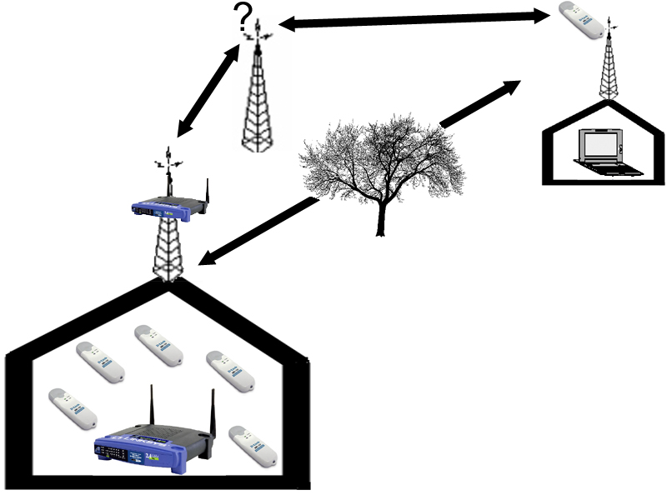
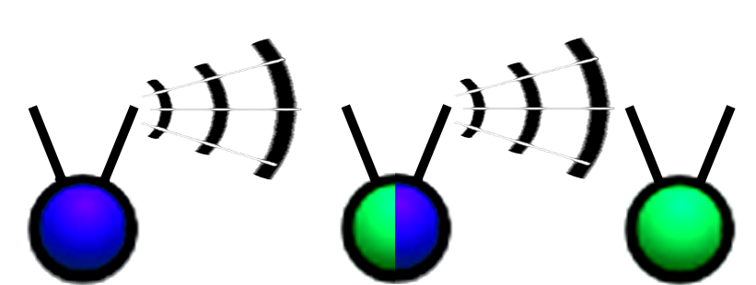

Image 3: Two examples of repeating wireless infrastructure.

Case 4: Mesh
Mesh topologies are an interesting option mainly in urban environments but also in remote areas whenever central infrastructure is hard to implement. Typical cases are municipal networks, campus networks and neighbourhood communities.

A mesh network is a network that employs one of two connection arrangements, full mesh topology or partial mesh topology. In the full mesh topology, each node is connected directly to each of the others. In the partial mesh topology, nodes are connected to only some, not all, of the other nodes.
Note that this definition mentions no dependency on any time parameter so nothing is necessarily dynamic in a mesh. However, in recent years and in connection with wireless networks, the term "mesh" is often used as a synonym for "ad hoc" or "mobile" network.

All mesh nodes need to run the same mesh routing software (protocol), but can be of different operating systems, and hardware types.

The setup of a mesh network is dependent on the mesh routing protocol and implementation. The table below shows some typical parameters.

Setting | Node x1 | Node x2
Mode | ad hoc | ad hoc
SSID | MY_SSID | MY_SSID
Channel | Channel x | Channel x
IP address | Typically static and manually set | Typically static and manually set
MAC address | Might be fixed to one another's MAC | Might be fixed to one another's MAC
Table 6: A typical setup for a mesh network.

Using DHCP in mesh networks is not trivial, so static IP addresses are recommended. The gateway nodes typically need additional settings to announce their presence, something that is not covered in this unit.

Real life examples of wireless infrastructures
Real life wireless networks are very often combinations of different topologies. Here are a few examples for discussion.

1. A typical office network with wireless part
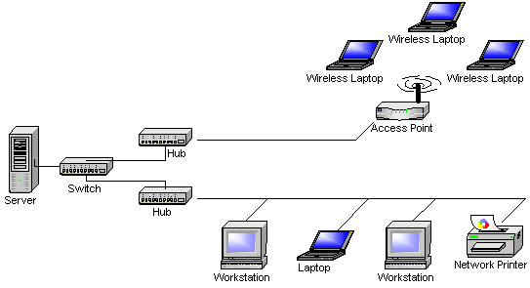

2. Nepalwireless.net backbone

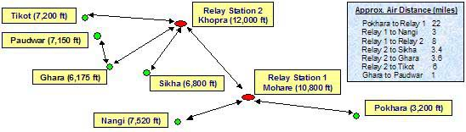

- Fantsuam Foundation's wireless network, Kafanchan, Nigeria (proposal)

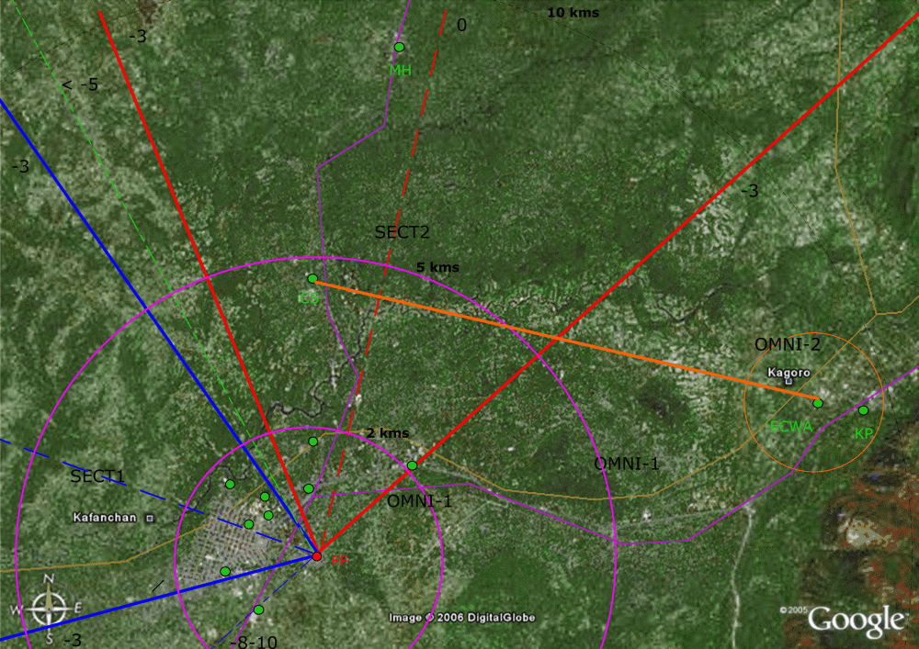

Red node (FF): Network Operation Center (NOC) with Internet connection (VSAT)
Green node: Wireless clients

Orange link : PtP link
Blue sector: Star topology (SECT1) covering 5 nodes
Red sector: Star topology (SECT2) covering 5 nodes

Conclusions
The topology of a network decides the physical and logical layout of the connection between its nodes. Depending of the purpose of a network and its nature, one topology is more suitable than another. Before deciding the topology of your network you need to have a clear picture of the purpose of your network. Does the network need to be scalable or should it be designed for just a handful of nodes? Is cost efficiency more important than reliability and redundancy? What range of coverage is needed? How many nodes should we count for? How does the terrain look like on the site? All these questions, and many more, need to be considered in the process of designing the topology of a wired or wireless network.

The five main issues to remember from this unit can be summarized as follows:

- Most wireless implementations are based on
  - Star, tree or line(repeating) topology
- Wireless implementations typically includes
  - Access points and/or routers
  - Wireless clients (laptop, PDA, surveillance equipment, wireless VoIP phones)
- An implementation can be of two modes
  - Ad hoc
  - Infrastructure
- The basics of setup includes
  - Mode, Channel, IP (for management and routing features) and MAC address(es) (optional)
- Many wireless implementations are based on more than one topology

